**Title**

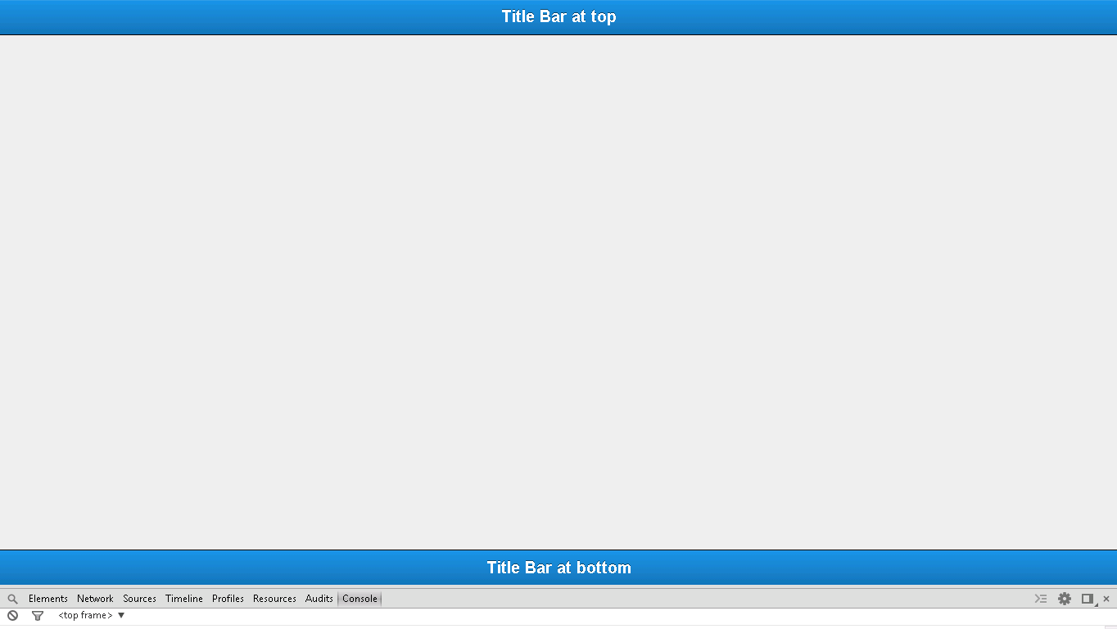

**Snapshot 1.1**

**Code**

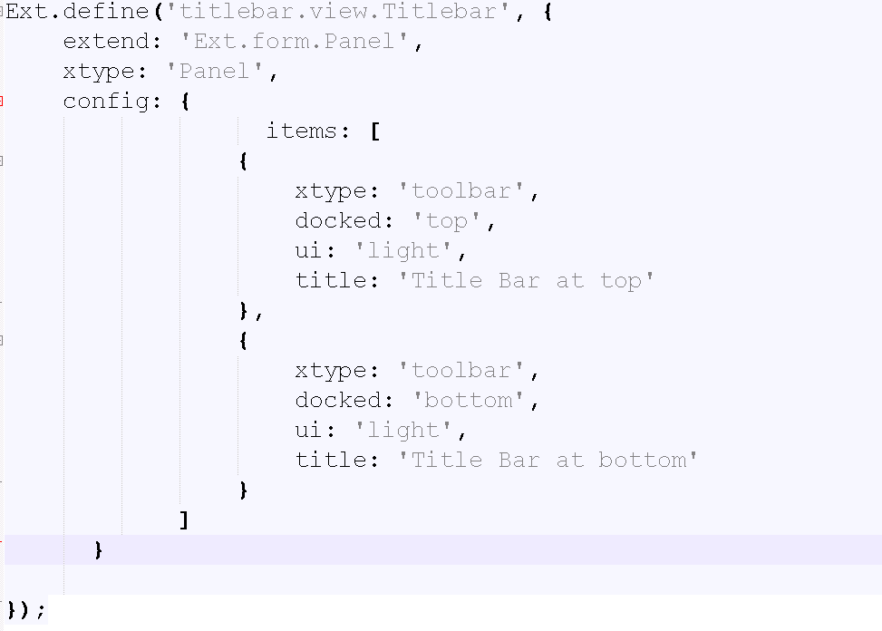

**Snapshot 1.2**

**items: [**

**{**

**xtype: 'toolbar',**

**docked: 'top',**

**ui: 'light',**

**title: 'Title Bar at top'**

**}**,:-> Adds Title bar at top on panel

**{**

**xtype: 'toolbar',**

**docked: 'bottom',**

**ui: 'light',**

**title: 'Title Bar at bottom'**

**}** :-> Adds Title bar at Bottom on panel

**]**

**Checkpoints:**

1. Check carefully with your indentations as if you will miss any of the braces by mistake may reflect in compilation error.
2. See that your .js file starts with Ext.Define block and check that ends at the end of the program.
3. More than one items are separated by comma (,) separator and main program block of define is ended by semi colon (;)
4. Any value is assigned using colon (:) for example ui: 'confirm' and value is written inside single coats.
5. Items block starts with square brackets [] , which contains multiple members and also sub items.
6. Don’t forget to add entries of your files in app.js.

**Source Code:**

